**Ideation Phase**

**Define the Problem Statements**

|  |  |
| --- | --- |
| Date | 31 January 2025 |
| Team ID | LTVIP2025TMID55640 |
| Project Name | Learn hub |
| Maximum Marks | 2 Marks |

**Customer Problem Statement Template:**

Create a problem statement to understand your customer's point of view. The Customer Problem Statement template helps you focus on what matters to create experiences people will love.

|  |  |  |  |  |  |
| --- | --- | --- | --- | --- | --- |
| **Problem**  **Statement (PS)** | **I am**  **(Customer)** | **I’m trying to** | **But** | **Because** | **Which makes me feel** |
| PS-1 | A working professional with a busy schedule | Book a doctor’s appointment quickly | Available slots are hard to find and the process is time-consuming | Most hospital/clinic websites are not user-friendly or don’t show real-time availability | Stressed and discouraged |
| PS-2 | A parent of a sick child | Find a nearby pediatrician urgently | I have to call multiple clinics or visit physically | There is no centralized platform showing doctors by location, availability, and specialization | Worried and helpless |

A well-articulated customer problem statement allows you and your team to find the ideal solution for the challenges your customers face. Throughout the process, you’ll also be able to empathize with your customers, which helps you better understand how they perceive your product or service.

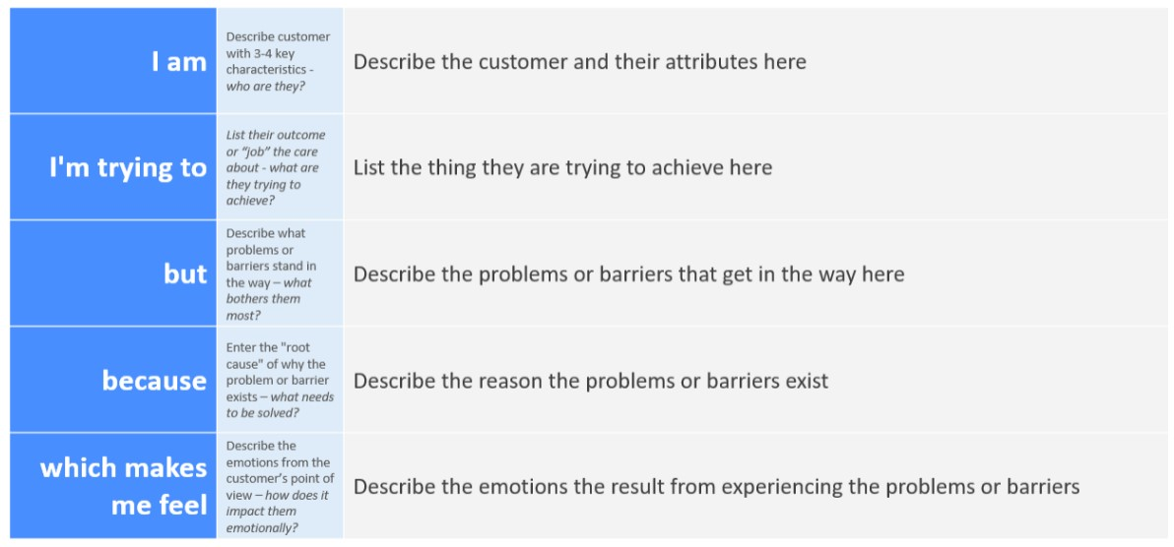

Reference: <https://miro.com/templates/customer-problem-statement/> **Example:**

